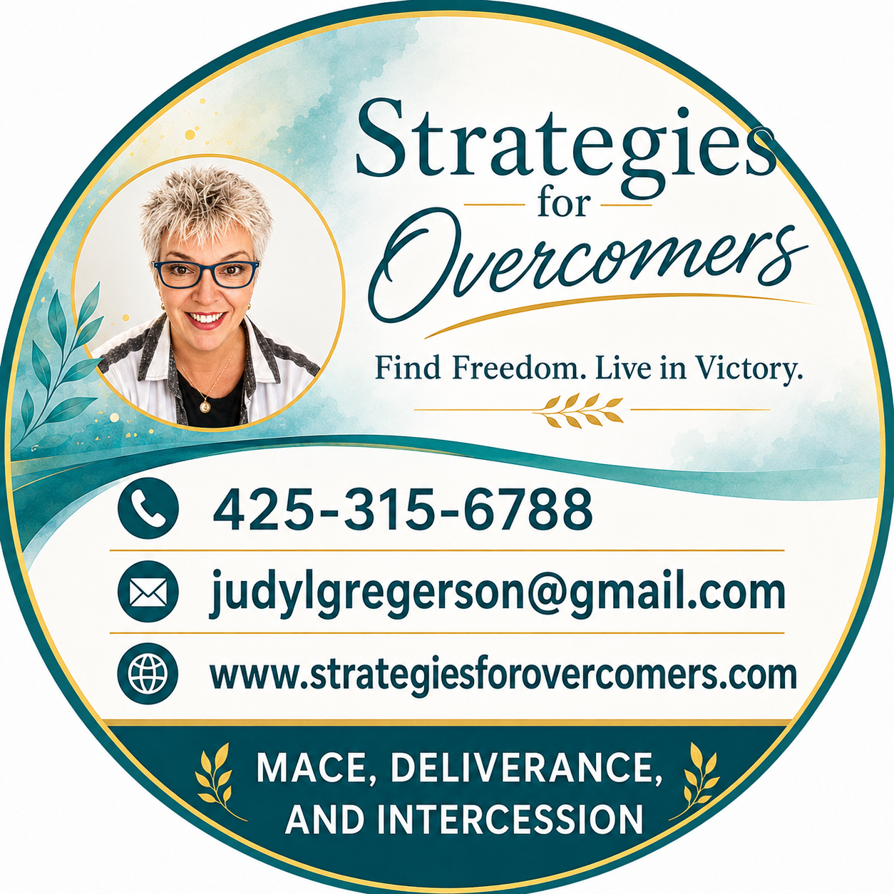
New Client Intake Form
Strategies for Overcomers — Find Freedom. Live in Victory.

Thank You for Reaching Out
Thank you so much for contacting me at Strategies for Overcomers! I'm truly glad you're here.
I'm a MACE practitioner, and I also do deliverance and intercession work. Each one brings something a little different, so let me quickly explain:
MEM (the MACE Energy Method) is wonderful for getting rid of trauma, trigger reactions, negative emotions, anxiety, fear, and negative thoughts, among other things.
Deliverance is for Christians, and it's especially good for getting rid of negative spiritual entities.
Intercession is for anyone, and it makes a great complement to MEM.
To get started, would you please answer the questions and fill out the form below, then send it back to me? Once I have it, I'll get back to you to schedule a time.
One quick but important note: I'm in the Pacific time zone, so knowing your time zone up front really helps us find a time that works for both of us.
Also, please know that sometimes I like to connect first with a quick Zoom call before we settle on a particular approach together. So don't be surprised if I reach out to set up a short conversation before we commit to a specific modality — it just helps me make sure we're starting in the right place for you.

Your Information
What are you interested in? | ☐ MACE (MEM)  ☐ Deliverance  ☐ Intercession
Name
Phone Number
Time Zone
Email Address
Availability (Days & Times)

How would you like to feel after treatment?

What type of problems would you like to work on?
Please list your top five below.
1.
2.
3.
4.
5.

I don't charge for deliverance or intercession, but I do appreciate any donations made to my ministry.
The cost for a MEM session is $250. I do have a sliding fee scale available for those who need it, so please don't hesitate to ask.
Payment for MEM is needed before the session. You'll find payment information either in my signature below or on my webpage.
Looking forward to connecting with you soon!

